BLOCK DIAGRAM:

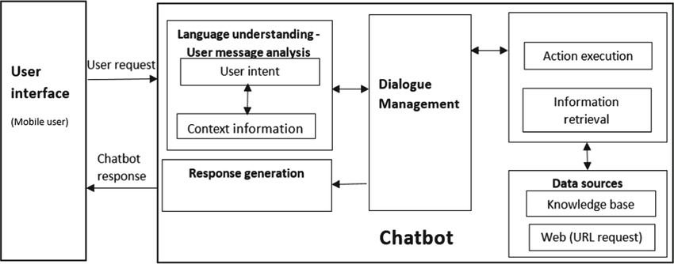

WORKING PRINCIPLE:

1.User Input Processing: The chatbot receives user input, which can be in the form of text or speech. It then preprocesses the input by tokenizing it into individual words or phrases, removing any irrelevant or noisy information, and performing any necessary text cleaning or normalization.

2.Natural Language Processing (NLP) Analysis: The preprocessed input is passed through various NLP techniques to extract meaningful information. These techniques can include part-of-speech tagging, named entity recognition, sentiment analysis, and syntactic parsing. These analyses help in understanding the user's intent, identifying important entities, and determining the sentiment or context of the input.

3.Intent Recognition: Based on the NLP analysis, the chatbot categorizes the user's input into predefined intents or purposes. This step involves training a machine learning model or using rule-based algorithms to classify the input. Intents represent the user's goals or the type of action the chatbot needs to perform in response.

4.Response Generation: Once the intent is recognized, the chatbot generates an appropriate response based on the user's input and the identified intent. This step involves using NLP techniques to construct meaningful and contextually relevant responses. It can include techniques like text generation, template-based responses, or retrieving information from a knowledge base or external APIs.

5.Context Management: To maintain a coherent conversation, the chatbot keeps track of the context of the conversation. It remembers previous interactions and uses that information to understand and respond appropriately to subsequent user input. This helps in providing personalized and contextual responses to the user.

6.Integration with APIs or Databases: In some cases, the chatbot may need to integrate with external APIs or databases to fetch or provide information. This can include accessing external services for weather data, retrieving product information from an e-commerce database, or querying a knowledge base for specific answers.

7.Error Handling: The chatbot handles situations where user input is unclear, ambiguous, or not recognized by providing appropriate error messages or prompts for clarification. It can ask the user to rephrase the input or provide more specific details to ensure accurate understanding.

8.User Experience: The chatbot is designed to provide a user-friendly and intuitive interface for interacting with users. It can include features like natural language understanding, error recovery mechanisms, prompts for user guidance, and a conversational flow that mimics human conversation.

WORKFLOW:

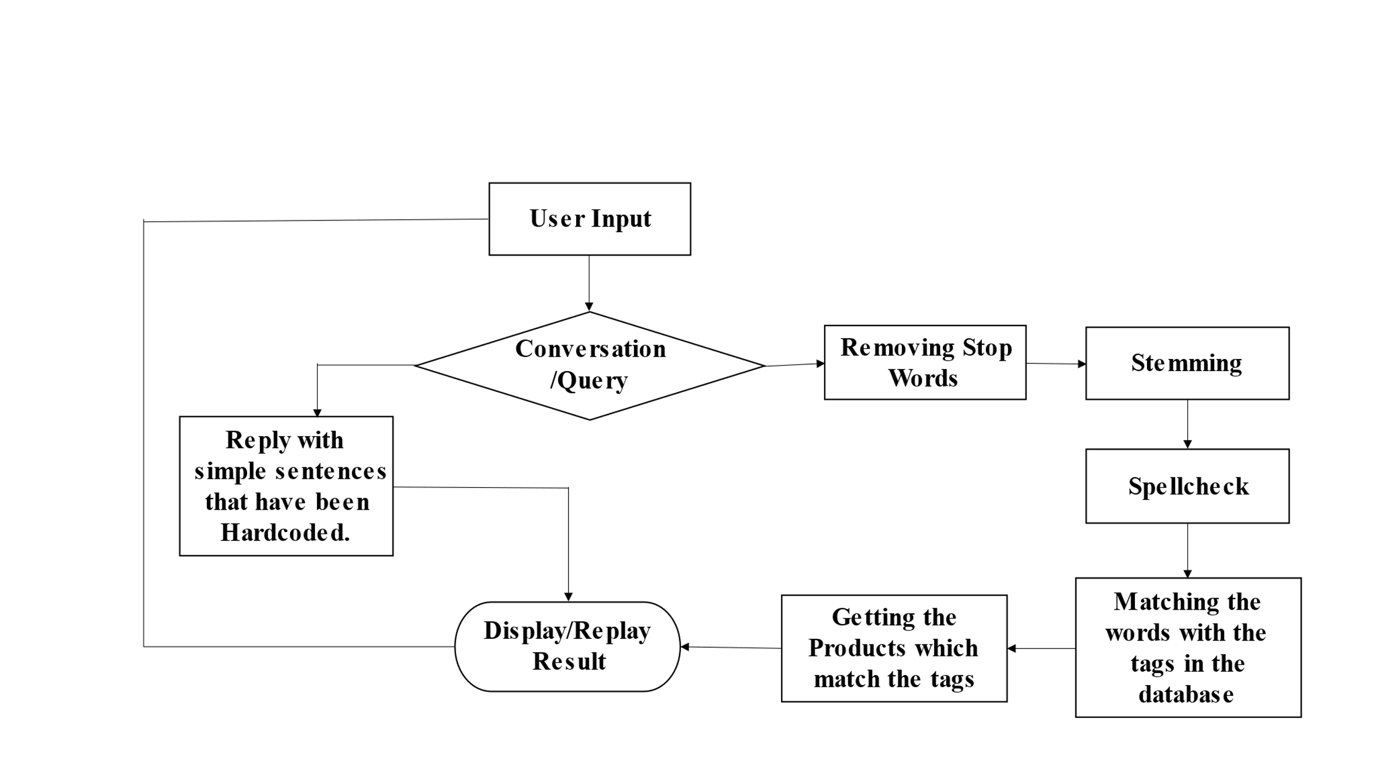

**CHAPTER 5**

**METHODOLOGY**

**5.1 LIST OF METHODOLOGY:**

* Data collection
* Data preprocessing
* Design Conversation Flow
* Develop NLP Models
* Model Training
* Intent Recognition and Entity Extraction:
* Implement Dialog Management:
* Integration and External Services
* Testing and Validation

**Data Collection:**

Collect a dataset of user queries and their corresponding intents or responses. This dataset will be used for training and evaluating the chatbot's performance. Ensure the dataset is diverse, representative of real-world scenarios, and adequately covers the range of intents and user inputs.

**Data Preprocessing:**

Preprocess the collected data by cleaning and normalizing it. Remove any noise, irrelevant information, or personally identifiable information (PII). Tokenize the text, perform stemming or lemmatization, and handle any data-specific challenges.

**Design Conversation Flow:**

Define the conversation flow for the chatbot. Determine the possible user intents, map out the possible dialog paths, and design the structure of the conversation. This includes deciding on branching logic, handling multi-turn conversations, and considering error handling and fallback mechanisms.

**Develop NLP Models:**

Implement the NLP models and techniques necessary for the chatbot. This may involve using libraries such as NLTK, spaCy, or specialized NLP frameworks like Rasa. Train and fine-tune the models using the collected data to enable accurate intent recognition, entity extraction, and sentiment analysis.

**Model Training:**

Train the selected NLP model using the preprocessed dataset. Fine-tune the model parameters based on the specific chatbot objectives and performance metrics. Optimize the training process to achieve the desired accuracy and efficiency.

**Intent Recognition and Entity Extraction:**

Develop algorithms and techniques to recognize user intents and extract relevant entities from user input. This can involve using techniques like classification algorithms, rule-based approaches, or sequence labeling methods depending on the complexity of the intents and entities.

**Implement Dialog Management:**

Develop the logic and algorithms to manage the chatbot's dialog flow. This includes handling user input, recognizing intents, maintaining conversation context, and generating appropriate responses. Design error handling mechanisms to gracefully handle ambiguous or invalid input.

**Integration and External Services:**

If required, integrate the chatbot with external APIs, databases, or services to enhance its functionality. This could involve connecting to a weather API, accessing a product database, or integrating with a customer support ticketing system.

**Testing and Validation:**

Thoroughly test the chatbot to ensure its performance, accuracy, and reliability. Test various user scenarios, including expected and edge cases, to validate the chatbot's behavior. Monitor and iterate on the chatbot's performance, continuously refining and improving its responses and understanding.

By following this methodology, you can systematically implement a chatbot project using NLP and Python. However, it's important to adapt the methodology to your specific project requirements and constraints, and be open to iterations and improvements throughout the development process.

**5.2 ALGORITHM:**

**Natural Language Processing (NLP) Algorithms:**

**Tokenization:** Algorithms like word_tokenize or regex-based tokenization can split text into individual tokens (words or phrases).

**Part-of-Speech (POS) Tagging:** Algorithms like the Hidden Markov Model (HMM) or the MaxEnt algorithm can assign grammatical tags to tokens.

**Named Entity Recognition (NER):** Algorithms like Conditional Random Fields (CRF) or Bidirectional LSTM-CRF models can identify and classify named entities in text.

**Sentiment Analysis:** Algorithms like Naive Bayes, Support Vector Machines (SVM), or Recurrent Neural Networks (RNN) can analyze and classify the sentiment expressed in text.

**Syntactic Parsing:** Algorithms like the CKY algorithm or Transition-based Parsing can analyze the grammatical structure of sentences.

**Neural Networks:**

Deep learning models like Convolutional Neural Networks (CNN), Recurrent Neural Networks (RNN), or Transformer models can be trained to recognize intents from user input.

**5.3 STEPS INVOLVED IN TRAINING**

**Train/Test Data Split:**

Split the preprocessed dataset into a training set and a testing set. The training set will be used to train the chatbot's models, while the testing set will be used to evaluate its performance. This split helps assess the model's generalization capabilities.

**Feature Extraction:**

Extract relevant features from the training data to represent the user queries and responses. This can involve techniques like word embeddings (e.g., Word2Vec or GloVe) or sequence encoders (e.g., LSTM or Transformer models). The goal is to convert text into numerical representations that can be used by machine learning models.

**Model Selection:**

Choose the appropriate model architecture for the chatbot. This can include sequence-to-sequence models (e.g., Encoder-Decoder, Transformer) or retrieval-based models (e.g., TF-IDF, word embeddings). Consider the nature of the conversation and the desired functionality of the chatbot**.**

**Hyperparameter Tuning:**

Fine-tune the model's hyperparameters to optimize its performance. Adjust parameters like learning rate, batch size, or network architecture to improve the model's accuracy and efficiency. Use techniques like grid search or random search to find the optimal combination of hyperparameters.

**CHAPTER 6**

**RESULTS**

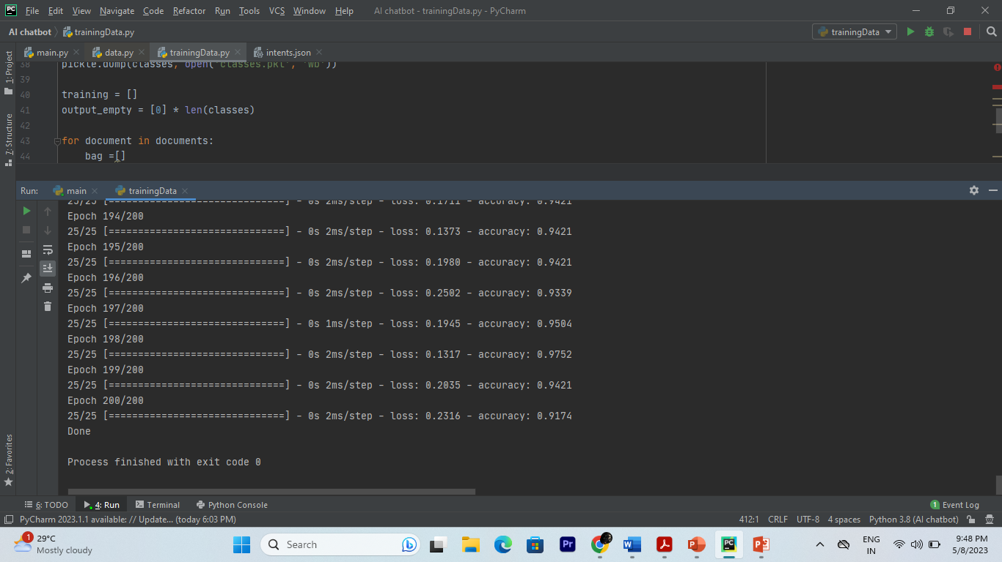

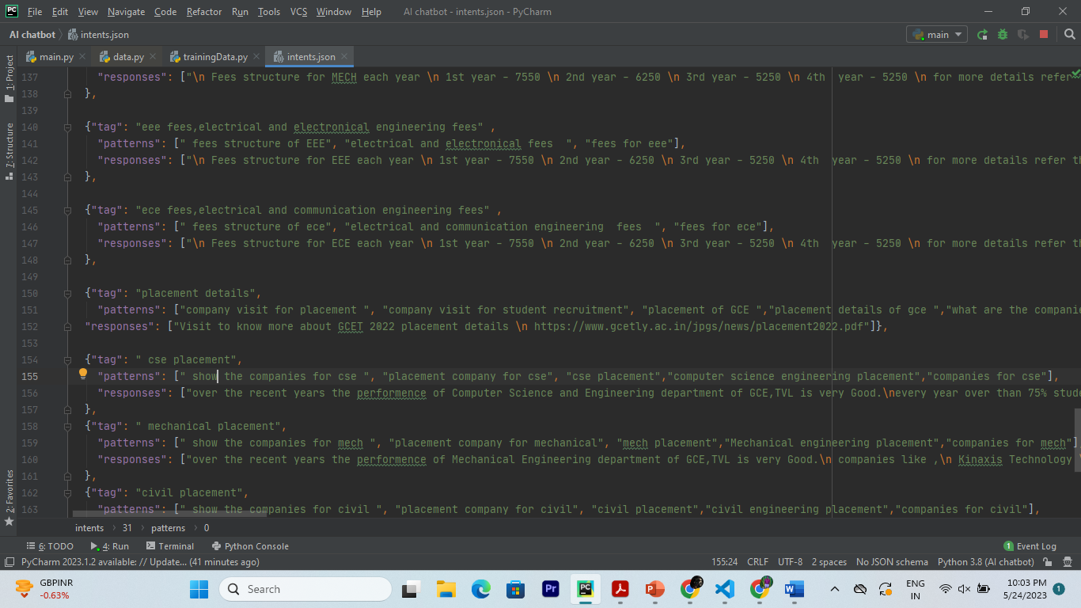

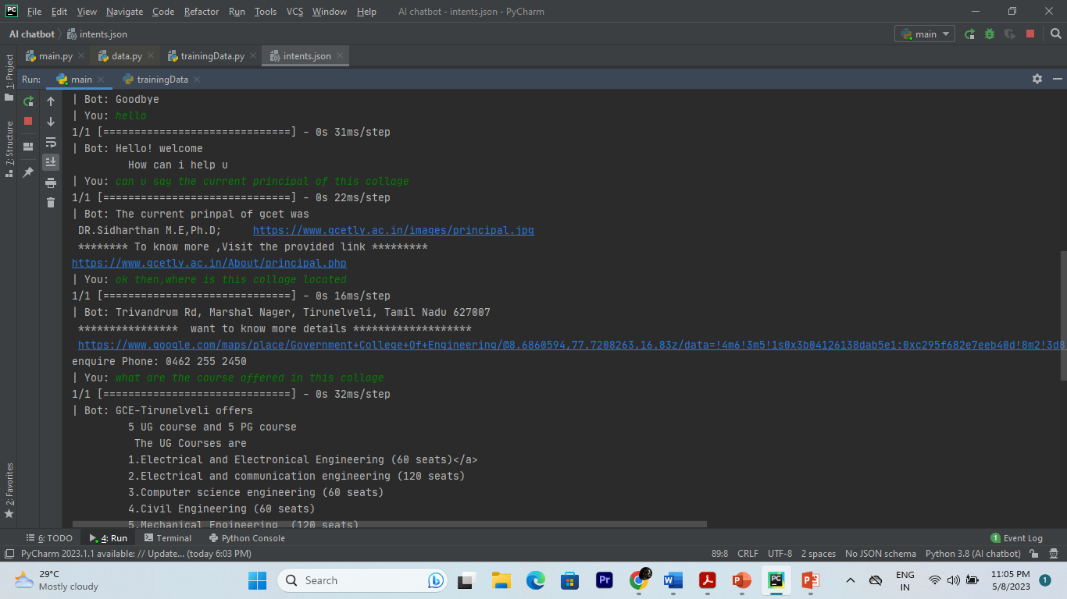



**CHAPTER 7**

### CONCLUSION

The chatbot is designed to understand and generate human-like responses to user queries, enabling interactive and conversational interactions. The project follows a systematic methodology that includes steps such as data collection, preprocessing, model training, evaluation, and deployment. Various NLP algorithms and techniques are employed, including tokenization, intent recognition, response generation, and dialog management.

By following the methodology and implementing the necessary algorithms, the chatbot is trained on a dataset of conversational data and learns patterns and relationships between user queries and responses. The training process involves preprocessing the data, selecting and training the appropriate NLP model, evaluating its performance, and fine-tuning hyperparameters for optimal results.